**HOME AUTOMATION – THE AGE OF IOT AND SMART HOMES**

**A PROJECT REPORT submitted as the regular project in**

**Community of Core Electronics**

**IN**

**HOUSE OF GEEKS**



**INDIAN INSTITUTE OF INFORMATION TECHNOLOGY, RANCHI**

**(An Institute of National Importance under the act of Parliament)**

**(Ranchi-83040), Jharkhand**



ACKNOWLEDGEMENT

No creation in this world is a solo effort neither this project. It would not have been possible without the kind support and help of many individuals. We take this opportunity to express our gratitude to all of them.

.We highly indebted to our seniors *Shashwat Pratap(Head of Community Core Electronics), Kolluru Yashwant(Coordinator of Community Core Electronics) and Wridheeman Bhattacharya (Joint Tech. Secretary, HoG)* for providing us an opportunity to do this project under their guidance. Their support and suggestions proved valuable in enabling the successful completion of this project.

Our sincere thanks to our friends and all those who have been instrumental in the successful completion of the project.

We acknowledge to all the people who have involved and supported us in making this project.

Team Members Community of Core Electronics (HOG)

* Prajjwal Verma (2020UGEC007R)
* Rittik Kushwaha (2020UGEC030R)
* Utkarsh Rai (2020UGEC032R)
* Vikas Kumar (2020UGEC018R)
* N. Chaitanya Veera Sri Sai (2020UGEC042R)
* KratikAggrawal (2020UGEC014R)
* Vivek Kumar (2020UGEC011R)
* P.V. Chiranjeevi (2020UGEC010R)

**CONTENTS**

|  |  |  |
| --- | --- | --- |
| S. No. | Particular | Page No. |
| 1. | **Introduction:**   * 1. ***Motivation***   2. ***Objective if the project*** | ***4-5*** |
| 2. | **Literature Survey:**  ***2.1. History of Home Automation***  ***2.2. Bluetooth based home automation using cell phones.***  ***2.3. Home automation using RF module.***  ***2.4. Wifi based home automation using cell phones.***  ***2.5. Wireless home automation using IOT.***  ***2.6. GSM based home automation using cell phones.*** | ***6-8*** |
| 3. | ***Implementation***  ***3.1. Prototype requirements***  ***3.2. Architecture and Components***  ***3.3. Block Diagram***  ***3.4. Circuit Diagram***  ***3.5. Pins Connections***  ***3.6. Code (based on app based security system)***  ***3.7. Code (based on password based security system)***  ***3.8. Output*** | ***9-37*** |
| 4. | ***4.1. Conclusion***  ***4.2. Future Scope*** | ***38-40*** |
|  | ***References*** | ***41*** |

**Chapter 1.**

**Introduction**

* 1. **Motivation**
* In order to enhance the standard of living, the appliances need to be wholly automated

without any user intervention in any form whatsoever. This enables the end user hassle- free

interaction with the appliances as the appliances learn and react as per the user’s requirements

without him physically pressing a button.

* The motivation for developing smart home automation comes from many reasons,

but most prominent are convenience, security, energy management, connectivity

and luxury.

* 1. **Objective**
* To make smart and intelligent usage of energy and its conservation in home appliances.
* It is developed for making everyday life of a user easy.
* Several security and control circuits have been designed to address the issues of abnormal events such as smoke detection, robbery etc.
* To help handicapped and aged people that will enable them to control home appliances and alert them in critical situations.
* A smart home with integrated e-health and assisted living technology can play a pivotal role in revolutionizing the healthcare system for elderly, the disabled and those with functional limitations.
* To implement a low cost, reliable and scalable home automation system that can be used to remotely switch on or off any household appliance, using a microcontroller to achieve hardware simplicity, low cost short messaging service for feedback and voice dial from any phone to toggle the switch state.
* Allow to control appliances when out of town.
* Save time, money and increase convenience.
* Adds safety through appliance and lighting control.

**Chapter 2.**

**Literature Survey**

**2.1. History of Home Automation:**

Home automation has been around since the World War I (1914), in fact, the television remote (a simple home automation system) was patented in 1893. Since then different home automation systems have evolved with a sharp rise after the II World War. It’s growth has been through various informal research and designs by technology enthusiasts who want a better way of getting things done at home without much effort on their part. The systems evolved from one that can automatically do routine chores like switch on and off security lights, to more sophisticated ones that can adjust lighting, put the television channel to favorite station and control doors.

***Various Home Automation Systems-***

**2.2. Bluetooth based home automation system using cell phones*:***

In Bluetooth based home automation system the home appliances are connected to the Arduino BT board at input output ports using relay. The program of Arduino BT board is based on high level interactive C language of microcontrollers; the connection is made via Bluetooth. The password protection is provided so only authorized user is allowed to access the appliances. The Bluetooth connection is established between Arduino BT board and phone for wireless communication. In this system the python script is used and it can install on any of the Symbian OS environment, it is portable. One circuit is designed and implemented for receiving the feedback from the phone, which indicate the status of the device.

**2.3. Home automation using RF module:**

The important goal of Home Automation System is to build a home automation system using a RF controlled remote. Now technology is accelerating so homes are also getting smarter. Modern homes are deliberately relocating from current l switches to centralized control system, containing RF controlled switches. Today traditional wall switches situated in various parts of the home makes it laborious t for the end user to go near them to control and operate. Even further it turns into more problematic for the old persons or physically handicapped people to do so. Home Automation using remote implements an easier solution with RF technology. In order to accomplish this, a RF remote is combined to the microcontroller on transmitter side that sends ON/OFF signals to the receiver where devices are connected. By operating the stated remote switch on the transmitter, the loads can be turned ON/OFF globally using wireless technology.

**2.4. Wi-Fi based home automation system using cell phones:**

Wi-Fi based home automation system mainly consist three modules, the server, the hardware interface module, and the software package. The figure shows the system model layout. Wi-Fi technology is used by server, and hardware Interface module to communicate with each other. The same technology uses to login to the server web based application. The server is connected to the internet, so remote users can access server web based application through the internet using compatible web browser. Software of the latest home automation system is split to server application software, and Microcontroller (Arduino) firmware. The Arduino software, built using C language, using IDE comes with the microcontroller itself. Arduino software is culpable for gathering events from connected sensors, then applies action to actuators and preprogramed in the server. Another job is to report the and record the history in the server DB. The server application software package for the proposed home automation system, is a web based application built using asp.net. The server application software can be accessed from internal network or from internet if the server has real IP on the internet using any internet navigator supports asp.net technology. Server application software is culpable of, maintain the whole home automation system, setup, configuration. Server use database to keep log of home automation system components, we choose to use XML files to save system log.

**2.5. Wireless Home Automation system using IoT:**

This system uses mobiles or computers to control basic home control and function automatically through internet from anywhere around the worldglobally, an automated home is sometimes called a smart home. It is meant to save the electric power and human energy. The proposed system is a distributed home automation system, consists of server i.e. Wi-Fi module, sensors. Server controls and monitors the various sensors, and can be easily configured to handle more hardware interface module (sensors). The Arduino board, with built in Wi-Fi module acts as web server. Automation System can be accessed from the web browser of any local PC using server IP, or remotely from any PC or mobile handheld device connected to the internet with appropriate web browser through server real IP (internet IP). Wi-Fi technology is selected to be the network infrastructure that connects server and the sensors. Wi-Fi is chosen to improve system security (by using secure Wi-Fi connection), and to increase system mobility and scalability.

**2.6. GSM based home automation system using cell phones:**

Because of the mobile phone and GSM technology, the GSM based home automation is lure to research. The SMS based home automation, GPRS based home automation and dual tone multi frequency (DTMF) based home automation, these options we considered mainly for communication in GSM. The system use transducer which convert machine function into electrical signals which goes into microcontroller. The sensors of system convert the physical qualities like sound, temperature and humidity into some other quantity like voltage. The microcontroller analysis all signal and convert them into command to understand by GSM module. Select appropriate communication method among SMS, GPRS and DTFC based on the command which received GSM module.

**Chapter 3.**

**Implementation**

# 3.1. Prototype requirements:

First of all it is necessary to establish the needs of the project.

In hardware terms the most important part is the local controller, an Arduino board, which will be the core of the application, the one that will be communicated with the mobile application and where the sensors and actuators will be connected. The sensors needed to capture desired environmental variables are temperature, lighting, movement and gas sensor and to control these variables a fan, some LED, an acoustic warning and a water pump are required.Finally, to make effective then ecessary communication between the board and the mobile will be needed aArduino ide application.

As for software, one of the advantages of using an Arduino board as a local controller is that it has its own development environment or IDE (*Integrated Development Environment*) that provides facilities for software development. For the other programming part, will be necessary another software to program the mobile application.

# 3.2. Architecture and components:

# Components required:

# Arduino Uno

# Servo motor

# Gas sensor

# LCD display

# LDR sensor

# Ultrasonic sensor

# Temperature sensor

# Relay module

# Security System I.C.

# 3.3. Block diagram:

APP ARDUINO UNO

SENSORS LCD SCREEN

PASS ARDUINO UNO

SENSORS LCD SCREEN

In smart home automation project for security purpose we add two options for security. In first block diagram we use Arduino ide for send input to microcontroller and if your input password is correct than room unlocked automatically. In second block diagram we introduce a simple password basedsecurity system, when user input password is correct than room unlocked automatically.

**3.4. Circuit diagram:**

**:- Circuit diagram when we use app based security system:**

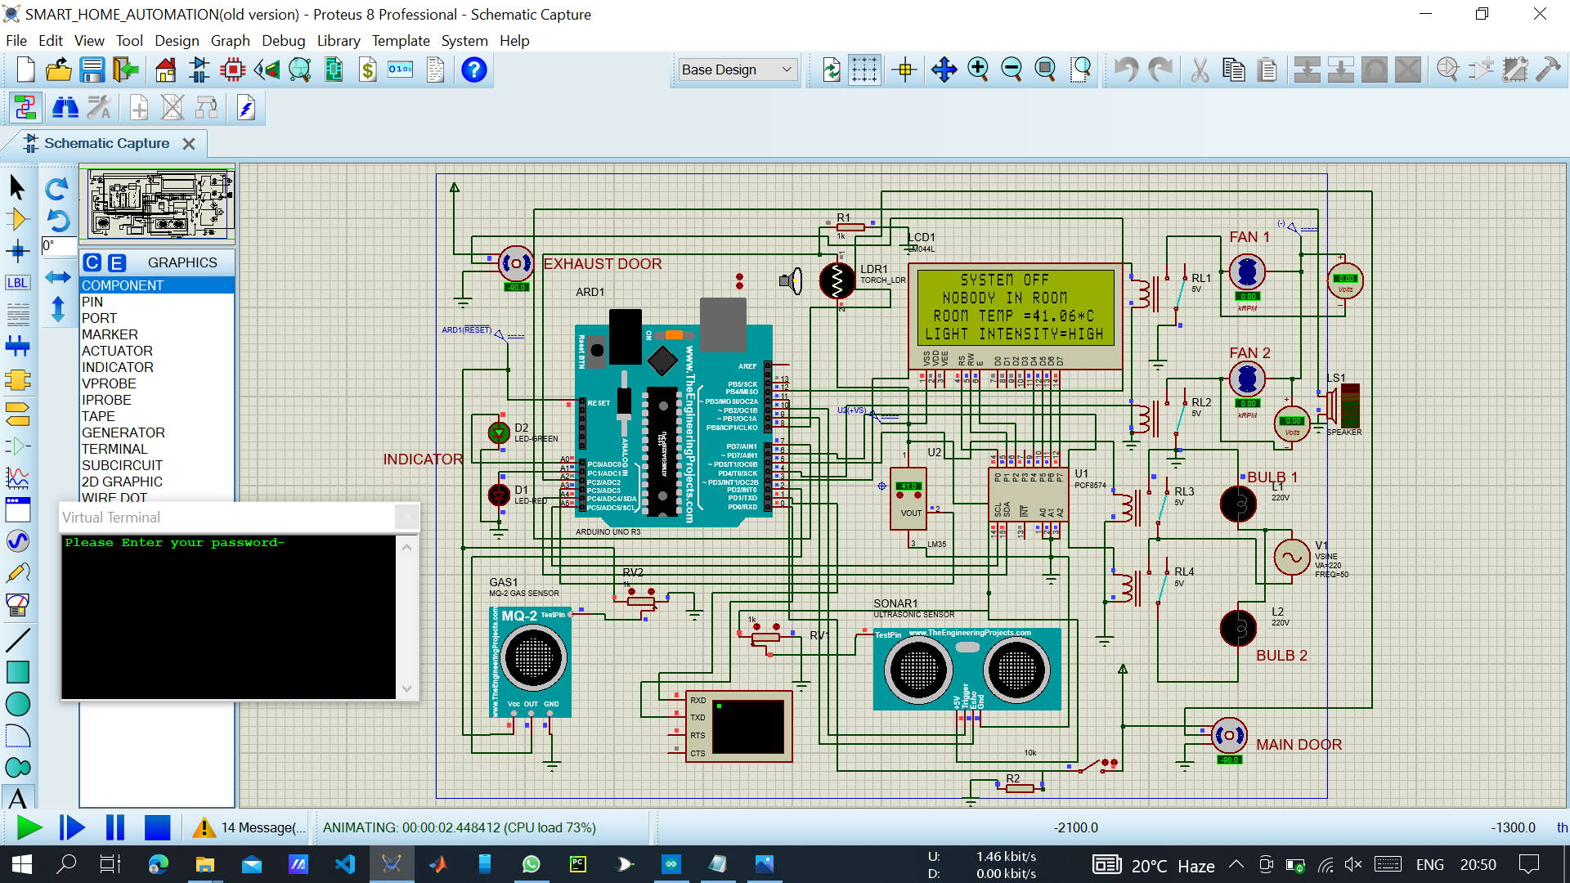

To unlock the main door, enter password in Arduino Uno ide (serial monitor).

**Circuit diagram when we use simple password based security system:**

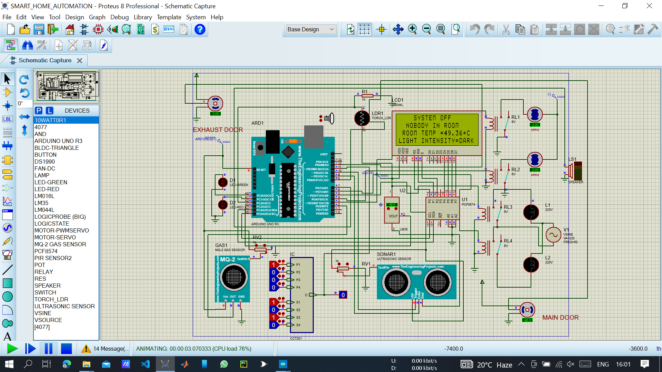

To unlock the main door, enter your password here.

As mentioned above in this project, we use microcontroller, sensors and LCD screen etc. Now we will see short description of all components:

* **Arduino Uno:**

In this project Arduino uno plays most important role. In easy word’s, basic work of Arduino is communicated between sensors and user. As example when user want to open the door than first, A password is required and when the password is correct than Arduino uno give input to servo motor and as output door will be open.

* **Servo motor:**

A servomotor is a rotary actuator or linear actuator that allows for precise control of angular or linear position. In this project servo motor is used as a door lock, means when Arduino send door open signal to servo motor than servo motor is rotate on 90-degree angle and as output our room door is open.

* **Gas sensor:**

This sensor is used to detect the presence of gases in the air such as methane, butane, LPG, and smoke. In this project when concentration of harmful gases is increased above a normal value than gas sensor send input to Arduino and as a output, fan will automatically on until the room concentration is normal in room. And exhaust doors are open so that person inside room may leave.

* **Temperature sensor:**

Temperature sensor has used for basic two applications in this project. First, according to temperature sensor output LCD screen show room temperature and second, according to temperature sensor output fan speed is controlled.

* **Ultrasonic sensor:**

Ultrasonic sensor, also known as an ultrasonic transducer, that is based on a transmitter and receiver and mainly used to determine the distance from the target object. In this project this sensor used for detection of person in room so that when nobody in room than automatically system goes in off condition. By use of this we can reduce power consumption.

* **LDR sensor:**

An electronic component like LDR or light-dependent resistor is responsive to light. Once light rays drop on it, then immediately the resistance will be changed. In this project uses of LDR sensor are that when the light intensity in room is low than automatically room lights are on. That’s why we can say that when light is required than automatically lights will be on.

* **LCD display:**

The LCD (Liquid Crystal Display) is a type of display that uses the liquid crystals for its operation. Here, we will accept the serial input from the computer and upload the sketch to the Arduino. The characters will be displayed on the LCD. In this project when we want to display temperature, fan and bulb states, gases concentration in room etc. on LCD screen than we can use this display. LCD display is fully controlled by Arduino uno and according to our input we can display data on LCD display.

* **Relay module:**

A relay basically allows a relatively low voltage to easily control higher power circuits. A relay accomplishes this by using the 5V outputted from an Arduino pin to energize the electromagnet which in turn closes an internal, physical switch to turn on or off a higher power circuit.

**3.5. Now we will see that how to connect these components with each other:**

In this project Arduino uno is main component of our circuit, so first we will see pinout of Arduino uno. All other sensors and components depend on Arduino uno input and output, so let’s discuss about Arduino uno.

**Arduino uno:**

|  |  |  |
| --- | --- | --- |
| **Pin Category** | **Pin Name** | **Details** |
| **Power** | Vin, 3.3V, 5V, GND | Vin: Input voltage to Arduino when using an external power source.  5V: Regulated power supply used to power microcontroller and other components on the board.  3.3V: 3.3V supply generated by on-board voltage regulator. Maximum current draw is 50mA.  GND: ground pins. |
| **Reset** | Reset | Resets the microcontroller. |
| **Analog Pins** | A0 – A5 | Used to provide analog input in the range of 0-5V |
| **Input/Output Pins** | Digital Pins 0 - 13 | Can be used as input or output pins. |
| **Serial** | 0(Rx), 1(Tx) | Used to receive and transmit TTL serial data. |
| **External Interrupts** | 2, 3 | To trigger an interrupt. |
| **PWM** | 3, 5, 6, 9, 11 | Provides 8-bit PWM output. |
| **SPI** | 10 (SS), 11 (MOSI), 12 (MISO) and 13 (SCK) | Used for SPI communication. |
| **Inbuilt LED** | 13 | To turn on the inbuilt LED. |
| **TWI** | A4 (SDA), A5 (SCA) | Used for TWI communication. |
| **AREF** | AREF | To provide reference voltage for input voltage. |

* **Servo motor:**

This sensor includes three pins and the pin configuration of this sensor is discussed below.

* **Pin 1(Brown):**Ground wire connected to the ground of system.
* **Pin 2(Red):**Powers the motor typically +5V is used.
* **Pin 3(Orange):**PWM signal is given in through this wire to drive the motor.
* **Gas sensor:**

This sensor includes three pins and the pin configuration of this sensor is discussed below.

* **Pin 1(Vcc):**Thispinpowersthemodule,typically theoperatingvoltageis+5V.
* **Pin 2(Ground):**Usedto connectthemoduletosystem ground.
* **Pin 3(Digital out):** Youcanalsousethissensortogetdigitaloutputfromthispin,bysettinga threshold valueusing the potentiometer.
* **Pin 4(Analog out):** Thispinoutputs0-5Vanalogvoltagebasedontheintensityofthe gas.
* **Temperature sensor:**

Now for connection between LM35 Temperature Sensor andArduino. Connect the 1st pin of LM35 to 5V of Arduino UNO and 3rdPin to GND. Similarly, connect the 2nd pin to Analog input pin A0 ofArduinoUNO,Now connectthe 16×2LCDtotheArduino.

* Connectpin1,3,5,16ofLCDtotheGND.
* Connectpin2,15ofLCDtotheVCC(5V).
* Connectpin4of LCDtopinD8ofArduino.
* Connectpin6of LCDtopinD9ofArduino.
* Connectpin11 ofLCDtopinD10ofArduino.
* Connectpin12ofLCDtopinD11ofArduino.
* Connectpin13 ofLCDtopinD12ofArduino.
* Connectpin14 ofLCDtopinD13ofArduino.
* **Ultrasonic sensor:**

This sensor includes three pins and the pin configuration of this sensor is discussedbelow.

* **Pin1 (Vcc):** This pin provides a +5V power supply to the sensor.
* **Pin2 (Trigger):** This is an input pin, used to initialize measurement by transmitting ultrasonic waves by keeping this pin high for 10us.
* **Pin3 (Echo):** This is an output pin, which goes high for a specific time period and it will be equivalent to the duration of the time for the wave to return back to the sensor.
* **Pin4 (Ground):** This is a GND pin used to connect to the GND of the system.
* **LDR sensor**
* Maximum power dissipation is 200mW.
* The maximum voltage at 0 lux is 200V.
* The peak wavelength is 600nm.
* Minimum resistance at 10lux is 1.8kΩ.
* Maximum resistance at 10lux is 4.5kΩ.
* Typical resistance at100lux is 0.7kΩ.
* Dark resistance after 1 sec is 0.03MΩ.
* Dark resistance after 5 sec is 0.25MΩ.
* **LCD display**

The 16×2 LCD pinout is shown below.

* **Pin1 (Ground/Source Pin):** This is a GND pin of display, used to connect the GND terminal of the microcontroller unit or power source.
* **Pin2 (VCC/Source Pin):** This is the voltage supply pin of the display, used to connect the supply pin of the power source.
* **Pin3 (V0/VEE/Control Pin):** This pin regulates the difference of the display, used to connect a changeable POT that can supply 0 to 5V.
* **Pin4 (Register Select/Control Pin):** This pin toggles among command or data register, used to connect a microcontroller unit pin and obtains either 0 or 1(0 = data mode, and 1 = command mode).
* **Pin5 (Read/Write/Control Pin):** This pin toggles the display among the read or writes operation, and it is connected to a microcontroller unit pin to get either 0 or 1 (0 = Write Operation, and 1 = Read Operation).
* **Pin 6 (Enable/Control Pin):**This pin should be held high to execute Read/Write process, and it is connected to the microcontroller unit & constantly held high.
* **Pins 7-14 (Data Pins):** These pins are used to send data to the display. These pins are connected in two-wire modes like 4-wire mode and 8-wire mode. In 4-wire mode, only four pins are connected to the microcontroller unit like 0 to 3, whereas in 8-wire mode, 8-pins are connected to microcontroller unit like 0 to 7.
* **Pin15 (+ve pin of the LED):** This pin is connected to +5V
* **Pin 16 (-ve pin of the LED):** This pin is connected to GND.
* **Relay module:**

The pin configuration of the 5V relay is shown below.

* **Pin1 (End 1):** It is used to activate the relay; usually this pin one end is connected to 5Volts whereas another end is connected to the ground.
* **Pin2 (End 2):** This pin is used to activate the Relay.
* **Pin3 (Common (COM)):** This pin is connected to the main terminal of the Load to make it active.
* **Pin4 (Normally Closed (NC)):** This second terminal of the load is connected to either NC/ NO pins. If this pin is connected to the load then it will be ON before the switch.
* **Pin5 (Normally Open (NO)):** If the second terminal of the load is allied to the NO pin, then the load will be turned off before the switch.
* **Security System I.C.**

The above picture is of internal circuit of password based security system. This system is made from basic logic gates (XNOR, AND, and OR Gates).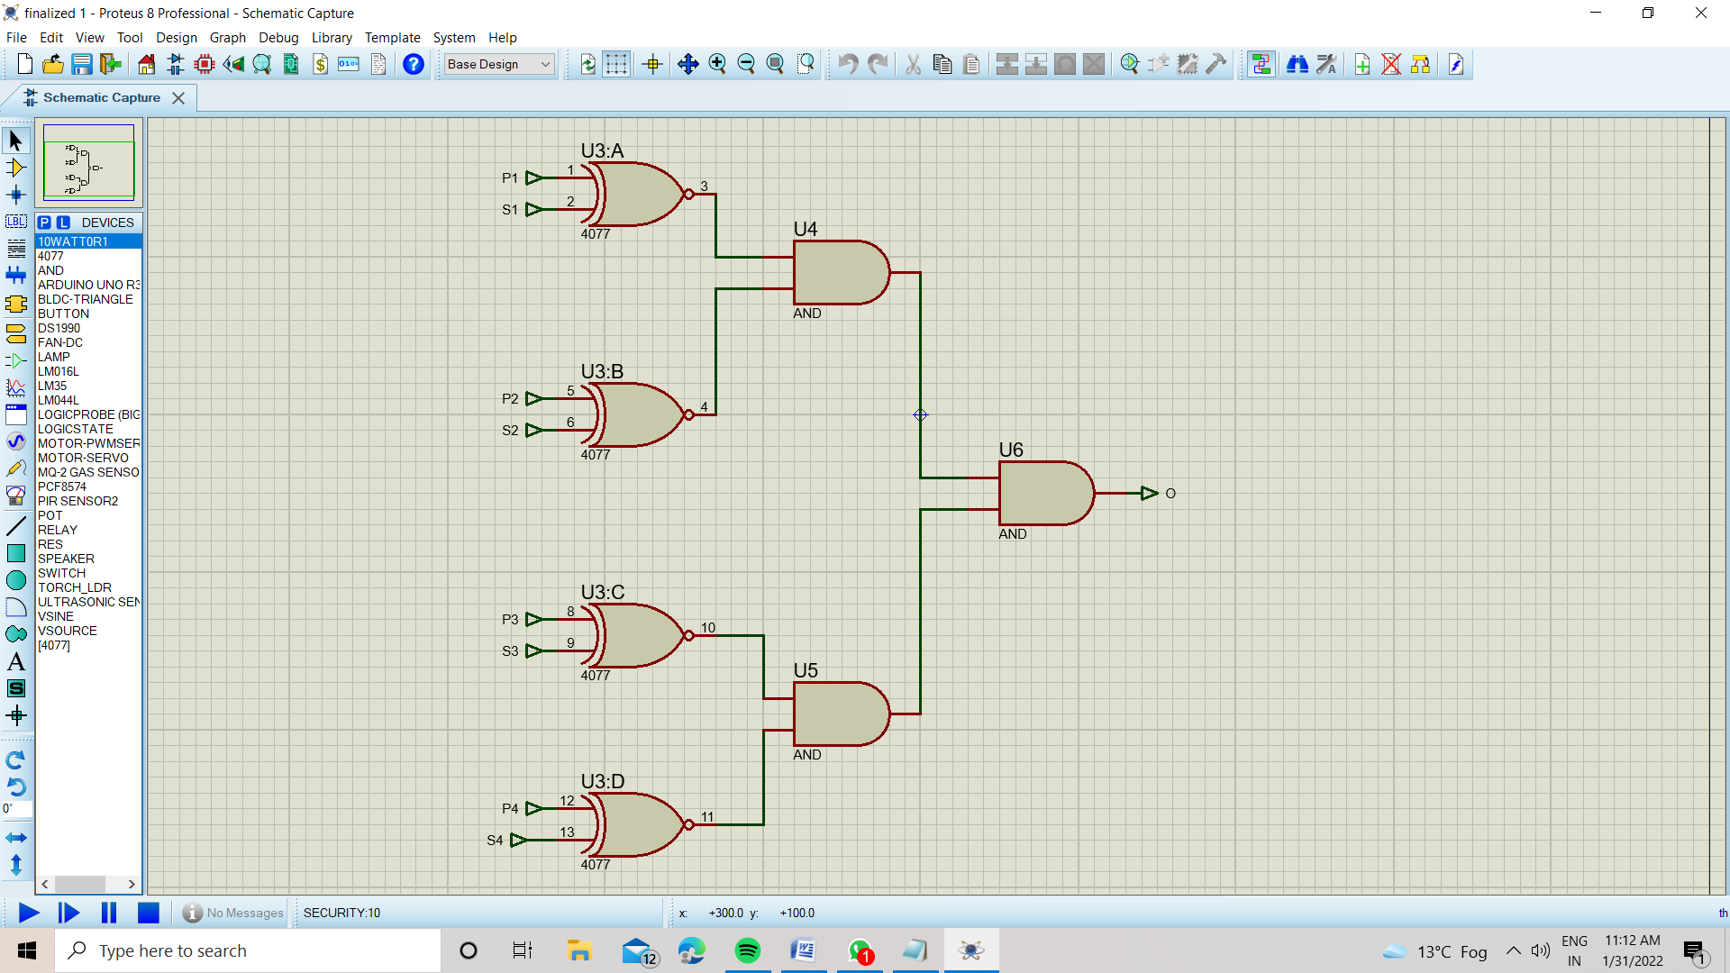

This I.C. has 8 pin configuration in which above 4 pins (P1, P2, P3, and P4) are used to enter already set password and last 4 pins (S1,S2,S3 and S4) are used to reset password by the owner.

If the entered password in sequence matches with that of set password in S1, S2, S3 and S4 then the output of I.C. will be high and consequently give high digital input to arduino board and the gate opens.

If the password doesn’t match then a low digital input will be given to arduino board and consequently gate remains closed.

**3.6. Code: Home Automation system based on app based security system.**

#include <LiquidCrystal_I2C.h>

#include <Servo.h>

LiquidCrystal_I2C lcd(0x20,20,4); // set the LCD address to 0x27 for a 16 chars and 2 line display

int pos = 0;

int k=0;

int count=0;

char c;

String id;

int green = A0;

int red = A1;

Servo motor1;

Servo motor2;

float temp;

float ldr_read;

int ldr = A2;

const int trigpin = 10;

const int echopin = 9;

const int gas = 2;

const int speaker = 7;

const int push_button = 11;

int push;

int gas_amount;

double distancecm;

double duration;

double distanceinch;

void setup()

{

motor1.attach(8);

motor1.write(0);

motor2.attach(12);

motor2.write(0);

pinMode(3,OUTPUT);

pinMode(4,OUTPUT);

pinMode(5,OUTPUT);

pinMode(green,OUTPUT);

pinMode(red,OUTPUT);

pinMode(6,OUTPUT);

pinMode(push_button,INPUT);

pinMode(7,OUTPUT);

pinMode(trigpin,OUTPUT);

pinMode(echopin,INPUT);

Serial.begin(9600);

Serial.println("Please Enter your password-");

lcd.init(); // initialize the lcd

lcd.backlight();

lcd.setCursor(5,0);

lcd.print("SMART HOME");

lcd.setCursor(4,1);

lcd.print("AUTOMATION.....");

lcd.setCursor(6,2);

lcd.print("SYSTEM");

lcd.setCursor(5,3);

lcd.print("ACTIVATED");

delay(600);

lcd.clear();

}

void loop()

{

digitalWrite(trigpin,LOW);

delayMicroseconds(2);

digitalWrite(trigpin,HIGH);

delayMicroseconds(10);

digitalWrite(trigpin,LOW);

duration = pulseIn(echopin,HIGH);

distancecm = (duration*0.034)/2;

distanceinch = (duration*0.0133)/2;

// Serial.print("Distance in cm =");

// Serial.println(distancecm);

temp = analogRead(A3);

ldr_read = analogRead(A2);

temp = (temp*500)/1023;

lcd.setCursor(0,0);

/* lcd.print("Temp =");

lcd.print(temp);

lcd.print("*C");

lcd.setCursor(0,1);

lcd.print("ldr =");

lcd.print(ldr_read);

delay(200);

lcd.clear();*/

push = digitalRead(push_button);

if(push == HIGH)

{

lcd.clear();

lcd.setCursor(1,0);

lcd.print(" ENTER YOUR SIX");

lcd.setCursor(2,1);

lcd.print("DIGIT PASSWORD-");

while(Serial.available()>0)

{

c=Serial.read();

k++;

id+=c;

if(k==6)

{

Serial.print(id);

if(id=="A1E5F6")

{

Serial.println("Valid TAG");

lcd.clear();

lcd.setCursor(3,0);

lcd.print("RIGHT PASSWORD");

lcd.setCursor(8,1);

lcd.print("GATE");

lcd.setCursor(9,2);

lcd.print("IS");

lcd.setCursor(7,3);

lcd.print("OPENING");

motor1.write(180);

delay(1000);

motor1.write(0);

}

else

{

count++;

Serial.println("Invalid TAG");

lcd.clear();

lcd.setCursor(3,0);

lcd.print("WRONG PASSWORD");

lcd.setCursor(4,1);

lcd.print("TRY IT AGAIN");

lcd.setCursor(5,2);

lcd.print("*******");

delay(400);

motor1.write(0);

if(count>3)

{

digitalWrite(7,HIGH);

delay(1000);

digitalWrite(7,LOW);

}

}

}

}

k=0;

id="";

delay(500);

}

//Serial.println(ldr_read);

if(push == LOW)

{

gas_amount = digitalRead(gas);

if(temp > 40 & distancecm < 660 & gas_amount == 0)

{

lcd.clear();

digitalWrite(3,HIGH);

digitalWrite(green,HIGH);

digitalWrite(red,LOW);

digitalWrite(4,HIGH);

digitalWrite(speaker,LOW);

lcd.setCursor(3,0);

lcd.print("BL1");

lcd.print(" BL2");

lcd.print(" FN1 ");

lcd.print("FN2");

lcd.setCursor(0,1);

lcd.setCursor(11,1);

lcd.print("ON");

lcd.setCursor(15,1);

lcd.print("ON");

lcd.setCursor(1,2);

lcd.print("ROOM TEMP =");

lcd.print(temp);

lcd.print("*C");

delay(150);

//lcd.clear();

}

if(temp < 40 & temp > 25 & distancecm < 660 & gas_amount == 0)

{

lcd.clear();

digitalWrite(3,HIGH);

digitalWrite(green,HIGH);

digitalWrite(red,LOW);

digitalWrite(4,LOW);

digitalWrite(speaker,LOW);

lcd.setCursor(3,0);

lcd.print("BL1");

lcd.print(" BL2");

lcd.print(" FN1 ");

lcd.print("FN2");

lcd.setCursor(0,1);

lcd.setCursor(11,1);

lcd.print("ON");

lcd.setCursor(15,1);

lcd.print("OFF");

lcd.setCursor(1,2);

lcd.print("ROOM TEMP =");

lcd.print(temp);

lcd.print("*C");

delay(150);

// lcd.clear();

}

if(temp < 25 & distancecm < 660 & gas_amount == 0)

{

lcd.clear();

digitalWrite(3,LOW);

digitalWrite(4,LOW);

digitalWrite(green,HIGH);

digitalWrite(red,LOW);

digitalWrite(speaker,LOW);

lcd.setCursor(3,0);

lcd.print("BL1");

lcd.print(" BL2");

lcd.print(" FN1 ");

lcd.print("FN2");

lcd.setCursor(0,1);

lcd.setCursor(11,1);

lcd.print("OFF");

lcd.setCursor(15,1);

lcd.print("OFF");

lcd.setCursor(1,2);

lcd.print("ROOM TEMP =");

lcd.print(temp);

lcd.print("*C");

delay(150);

// lcd.clear();

}

if(ldr_read < 20 & distancecm < 660 & gas_amount == 0)

{

lcd.clear();

motor2.write(0);

digitalWrite(5,HIGH);

digitalWrite(6,HIGH);

digitalWrite(speaker,LOW);

lcd.setCursor(3,0);

lcd.print("BL1");

lcd.print(" BL2");

lcd.print(" FN1 ");

lcd.print("FN2");

lcd.setCursor(3,1);

lcd.print("ON");

lcd.setCursor(7,1);

lcd.print("ON");

lcd.setCursor(1,2);

lcd.print("ROOM TEMP =");

lcd.print(temp);

lcd.print("*C");

lcd.setCursor(0,3);

lcd.print("LIGHT INTENSITY=");

lcd.print("DARK");

delay(150);

// lcd.clear();

}

if(ldr_read >= 20 & ldr_read < 93 & distancecm < 660 & gas_amount == 0)

{

lcd.clear();

motor2.write(0);

digitalWrite(5,HIGH);

digitalWrite(6,LOW);

digitalWrite(speaker,LOW);

lcd.setCursor(3,0);

lcd.print("BL1");

lcd.print(" BL2");

lcd.print(" FN1 ");

lcd.print("FN2");

lcd.setCursor(3,1);

lcd.print("ON");

lcd.setCursor(7,1);

lcd.print("OFF");

lcd.setCursor(1,2);

lcd.print("ROOM TEMP =");

lcd.print(temp);

lcd.print("*C");

lcd.setCursor(0,3);

lcd.print("LIGHT INTENSITY=");

lcd.print("AVG.");

delay(150);

// lcd.clear();

}

if(ldr_read >= 93 & distancecm < 660 & gas_amount == 0)

{

lcd.clear();

motor2.write(0);

digitalWrite(5,LOW);

digitalWrite(6,LOW);

digitalWrite(speaker,LOW);

lcd.setCursor(3,0);

lcd.print("BL1");

lcd.print(" BL2");

lcd.print(" FN1 ");

lcd.print("FN2");

lcd.setCursor(3,1);

lcd.print("OFF");

lcd.setCursor(7,1);

lcd.print("OFF");

lcd.setCursor(1,2);

lcd.print("ROOM TEMP =");

lcd.print(temp);

lcd.print("*C");

lcd.setCursor(0,3);

lcd.print("LIGHT INTENSITY=");

lcd.print("HIGH");

delay(150);

//lcd.clear();

}

if(temp < 50 & distancecm > 660 & gas_amount == 0)

{

lcd.clear();

motor2.write(0);

digitalWrite(3,LOW);

digitalWrite(4,LOW);

digitalWrite(5,LOW);

digitalWrite(6,LOW);

digitalWrite(speaker,LOW);

digitalWrite(green,HIGH);

digitalWrite(red,LOW);

lcd.setCursor(4,0);

lcd.print("SYSTEM OFF");

lcd.setCursor(2,1);

lcd.print("NOBODY IN ROOM");

lcd.setCursor(1,2);

lcd.print("ROOM TEMP =");

lcd.print(temp);

lcd.print("*C");

// lcd.print("OFF ");

if(ldr_read < 20 )

{

lcd.setCursor(0,3);

lcd.print("LIGHT INTENSITY=");

lcd.print("DARK");

}

if(ldr_read >= 20 & ldr_read < 93)

{

lcd.setCursor(0,3);

lcd.print("LIGHT INTENSITY=");

lcd.print("AVG.");

}

if(ldr_read >= 93 )

{

lcd.setCursor(0,3);

lcd.print("LIGHT INTENSITY=");

lcd.print("HIGH");

}

delay(150);

}

if(gas_amount == 1)

{

lcd.clear();

motor2.write(180);

digitalWrite(3,HIGH);

digitalWrite(4,HIGH);

digitalWrite(5,HIGH);

digitalWrite(6,HIGH);

lcd.setCursor(7,0);

digitalWrite(green,LOW);

digitalWrite(red,HIGH);

lcd.print("DANGER");

lcd.setCursor(4,1);

lcd.print("EXIT FROM ROOM");

lcd.setCursor(5,2);

lcd.print("HARMFULL GAS");

lcd.setCursor(1,3);

lcd.print("EXHAUST DOOR OPEN");

digitalWrite(speaker,HIGH);

delay(150);

}

if(temp >= 50 & distancecm > 660 & gas_amount == 0)

{

lcd.clear();

motor2.write(180);

digitalWrite(3,HIGH);

digitalWrite(4,HIGH);

digitalWrite(green,LOW);

digitalWrite(red,HIGH);

digitalWrite(speaker,HIGH);

lcd.setCursor(5,0);

lcd.print("FIRE....");

lcd.setCursor(2,1);

lcd.print("EXIT FROM ROOM");

lcd.setCursor(1,2);

lcd.print("ROOM TEMP =");

lcd.print(temp);

lcd.print("*C");

lcd.setCursor(1,3);

lcd.print("EXHAUST DOOR OPEN");

delay(150);

//lcd.clear();

}

}

}

**3.7. Code: Home Automation system based on password based security system.**

#include <LiquidCrystal_I2C.h>

#include <Servo.h>

LiquidCrystal_I2C lcd(0x20,20,4); // set the LCD address to 0x27 for a 16 chars and 2 line display

int pos = 0;

Servo motor1;

float temp;

float ldr_read;

int ldr = A2;

const int trigpin = 10;

const int echopin = 9;

const int gas = 2;

const int speaker = 7;

const int password = 11;

int security;

int gas_amount;

double distancecm;

double duration;

double distanceinch;

void setup()

{

motor1.attach(8);

motor1.write(0);

pinMode(3,OUTPUT);

pinMode(4,OUTPUT);

pinMode(5,OUTPUT);

pinMode(6,OUTPUT);

pinMode(password,INPUT);

pinMode(7,OUTPUT);

pinMode(trigpin,OUTPUT);

pinMode(echopin,INPUT);

Serial.begin(9600);

lcd.init(); // initialize the lcd

lcd.backlight();

lcd.setCursor(5,0);

lcd.print("SMART HOME");

lcd.setCursor(4,1);

lcd.print("AUTOMATION.....");

lcd.setCursor(6,2);

lcd.print("SYSTEM");

lcd.setCursor(5,3);

lcd.print("ACTIVATED");

delay(600);

lcd.clear();

}

void loop()

{

digitalWrite(trigpin,LOW);

delayMicroseconds(2);

digitalWrite(trigpin,HIGH);

delayMicroseconds(10);

digitalWrite(trigpin,LOW);

duration = pulseIn(echopin,HIGH);

distancecm = (duration*0.034)/2;

distanceinch = (duration*0.0133)/2;

// Serial.print("Distance in cm =");

// Serial.println(distancecm);

temp = analogRead(A3);

ldr_read = analogRead(A2);

temp = (temp*500)/1023;

lcd.setCursor(0,0);

/* lcd.print("Temp =");

lcd.print(temp);

lcd.print("*C");

lcd.setCursor(0,1);

lcd.print("ldr =");

lcd.print(ldr_read);

delay(200);

lcd.clear();*/

security = digitalRead(password);

if(security == 1)

{

lcd.clear();

lcd.setCursor(3,0);

lcd.print("RIGHT PASSWORD");

lcd.setCursor(8,1);

lcd.print("GATE");

lcd.setCursor(9,2);

lcd.print("IS");

lcd.setCursor(7,3);

lcd.print("OPENING");

motor1.write(180);

delay(1000);

}

gas_amount = digitalRead(gas);

if(temp > 40 & distancecm < 660 & gas_amount == 0)

{

motor1.write(0);

lcd.clear();

digitalWrite(3,HIGH);

digitalWrite(4,HIGH);

digitalWrite(speaker,LOW);

lcd.setCursor(3,0);

lcd.print("BL1");

lcd.print(" BL2");

lcd.print(" FN1 ");

lcd.print("FN2");

lcd.setCursor(0,1);

lcd.setCursor(11,1);

lcd.print("ON");

lcd.setCursor(15,1);

lcd.print("ON");

lcd.setCursor(1,2);

lcd.print("ROOM TEMP =");

lcd.print(temp);

lcd.print("*C");

delay(150);

//lcd.clear();

}

if(temp < 40 & temp > 25 & distancecm < 660 & gas_amount == 0)

{

motor1.write(0);

lcd.clear();

digitalWrite(3,HIGH);

digitalWrite(4,LOW);

digitalWrite(speaker,LOW);

lcd.setCursor(3,0);

lcd.print("BL1");

lcd.print(" BL2");

lcd.print(" FN1 ");

lcd.print("FN2");

lcd.setCursor(0,1);

lcd.setCursor(11,1);

lcd.print("ON");

lcd.setCursor(15,1);

lcd.print("OFF");

lcd.setCursor(1,2);

lcd.print("ROOM TEMP =");

lcd.print(temp);

lcd.print("*C");

delay(150);

// lcd.clear();

}

if(temp < 25 & distancecm < 660 & gas_amount == 0)

{

motor1.write(0);

lcd.clear();

digitalWrite(3,LOW);

digitalWrite(4,LOW);

digitalWrite(speaker,LOW);

lcd.setCursor(3,0);

lcd.print("BL1");

lcd.print(" BL2");

lcd.print(" FN1 ");

lcd.print("FN2");

lcd.setCursor(0,1);

lcd.setCursor(11,1);

lcd.print("OFF");

lcd.setCursor(15,1);

lcd.print("OFF");

lcd.setCursor(1,2);

lcd.print("ROOM TEMP =");

lcd.print(temp);

lcd.print("*C");

delay(150);

// lcd.clear();

}

if(ldr_read < 20 & distancecm < 660 & gas_amount == 0)

{

motor1.write(0);

lcd.clear();

digitalWrite(5,HIGH);

digitalWrite(6,HIGH);

digitalWrite(speaker,LOW);

lcd.setCursor(3,0);

lcd.print("BL1");

lcd.print(" BL2");

lcd.print(" FN1 ");

lcd.print("FN2");

lcd.setCursor(3,1);

lcd.print("ON");

lcd.setCursor(7,1);

lcd.print("ON");

lcd.setCursor(1,2);

lcd.print("ROOM TEMP =");

lcd.print(temp);

lcd.print("*C");

lcd.setCursor(0,3);

lcd.print("LIGHT INTENSITY=");

lcd.print("DARK");

delay(150);

// lcd.clear();

}

if(ldr_read >= 20 & ldr_read < 93 & distancecm < 660 & gas_amount == 0)

{

motor1.write(0);

lcd.clear();

digitalWrite(5,HIGH);

digitalWrite(6,LOW);

digitalWrite(speaker,LOW);

lcd.setCursor(3,0);

lcd.print("BL1");

lcd.print(" BL2");

lcd.print(" FN1 ");

lcd.print("FN2");

lcd.setCursor(3,1);

lcd.print("ON");

lcd.setCursor(7,1);

lcd.print("OFF");

lcd.setCursor(1,2);

lcd.print("ROOM TEMP =");

lcd.print(temp);

lcd.print("*C");

lcd.setCursor(0,3);

lcd.print("LIGHT INTENSITY=");

lcd.print("AVG.");

delay(150);

// lcd.clear();

}

if(ldr_read >= 93 & distancecm < 660 & gas_amount == 0)

{

motor1.write(0);

lcd.clear();

digitalWrite(5,LOW);

digitalWrite(6,LOW);

digitalWrite(speaker,LOW);

lcd.setCursor(3,0);

lcd.print("BL1");

lcd.print(" BL2");

lcd.print(" FN1 ");

lcd.print("FN2");

lcd.setCursor(3,1);

lcd.print("OFF");

lcd.setCursor(7,1);

lcd.print("OFF");

lcd.setCursor(1,2);

lcd.print("ROOM TEMP =");

lcd.print(temp);

lcd.print("*C");

lcd.setCursor(0,3);

lcd.print("LIGHT INTENSITY=");

lcd.print("HIGH");

delay(150);

//lcd.clear();

}

if(temp < 50 & distancecm > 660 & gas_amount == 0)

{

motor1.write(0);

lcd.clear();

digitalWrite(3,LOW);

digitalWrite(4,LOW);

digitalWrite(5,LOW);

digitalWrite(6,LOW);

digitalWrite(speaker,LOW);

lcd.setCursor(4,0);

lcd.print("SYSTEM OFF");

lcd.setCursor(2,1);

lcd.print("NOBODY IN ROOM");

lcd.setCursor(1,2);

lcd.print("ROOM TEMP =");

lcd.print(temp);

lcd.print("*C");

// lcd.print("OFF ");

if(ldr_read < 20 )

{

lcd.setCursor(0,3);

lcd.print("LIGHT INTENSITY=");

lcd.print("DARK");

}

if(ldr_read >= 20 & ldr_read < 93)

{

lcd.setCursor(0,3);

lcd.print("LIGHT INTENSITY=");

lcd.print("AVG.");

}

if(ldr_read >= 93 )

{

lcd.setCursor(0,3);

lcd.print("LIGHT INTENSITY=");

lcd.print("HIGH");

}

delay(150);

}

if(gas_amount == 1)

{

motor1.write(0);

lcd.clear();

digitalWrite(3,HIGH);

digitalWrite(4,HIGH);

digitalWrite(5,HIGH);

digitalWrite(6,HIGH);

lcd.setCursor(7,0);

lcd.print("DANGER");

lcd.setCursor(4,1);

lcd.print("EXIT FROM ROOM");

lcd.setCursor(5,2);

lcd.print("HARMFULL GAS");

lcd.setCursor(6,3);

lcd.print("DETECTED");

digitalWrite(speaker,HIGH);

delay(150);

}

if(temp >= 50 & distancecm > 660 & gas_amount == 0)

{

motor1.write(0);

lcd.clear();

digitalWrite(3,HIGH);

digitalWrite(4,HIGH);

digitalWrite(speaker,HIGH);

lcd.setCursor(5,0);

lcd.print("FIRE....");

lcd.setCursor(2,1);

lcd.print("EXIT FROM ROOM");

lcd.setCursor(1,2);

lcd.print("ROOM TEMP =");

lcd.print(temp);

lcd.print("*C");

delay(150);

//lcd.clear();

}

}

**3.8. OUTPUT:**

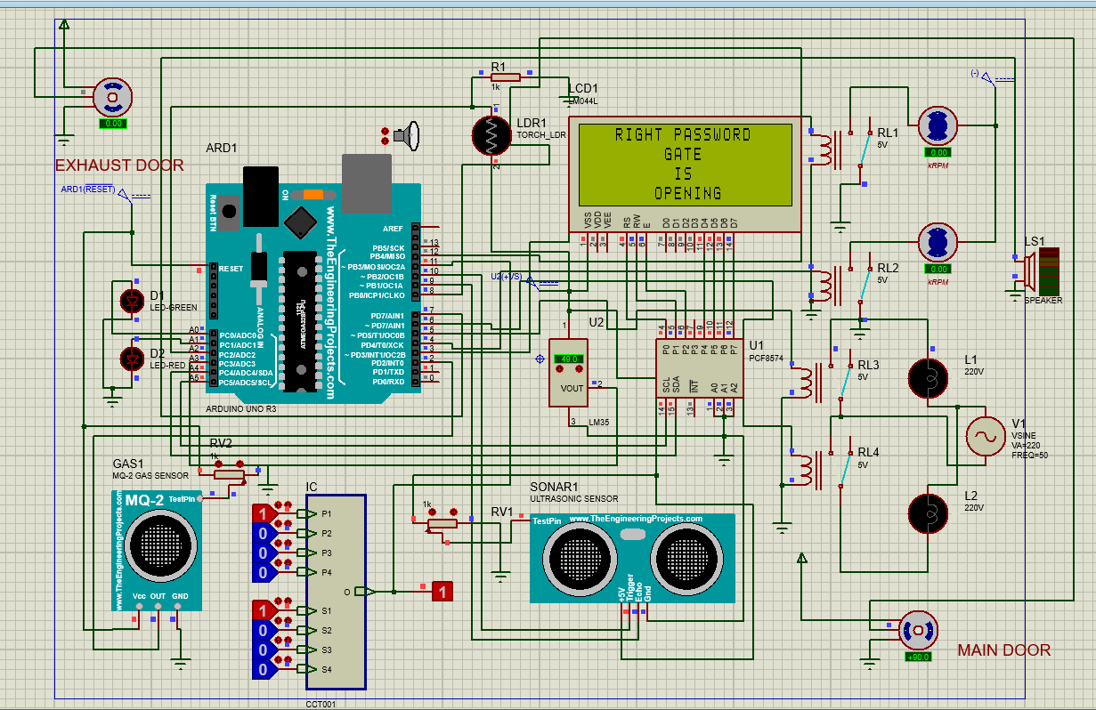

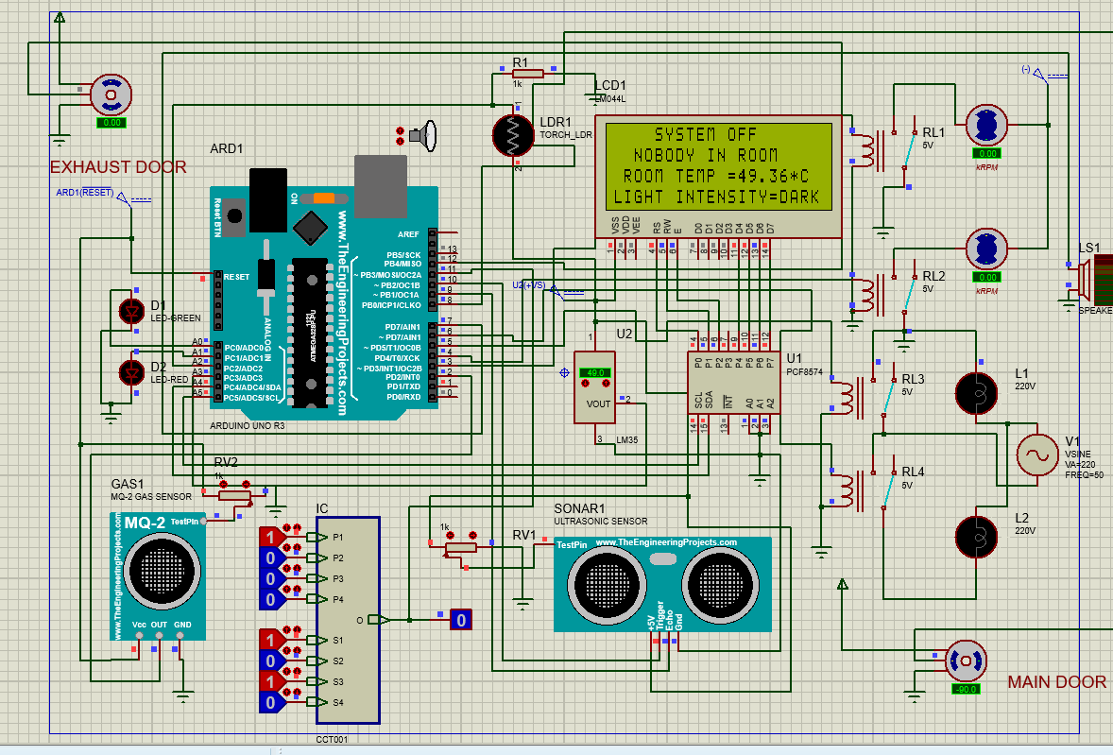

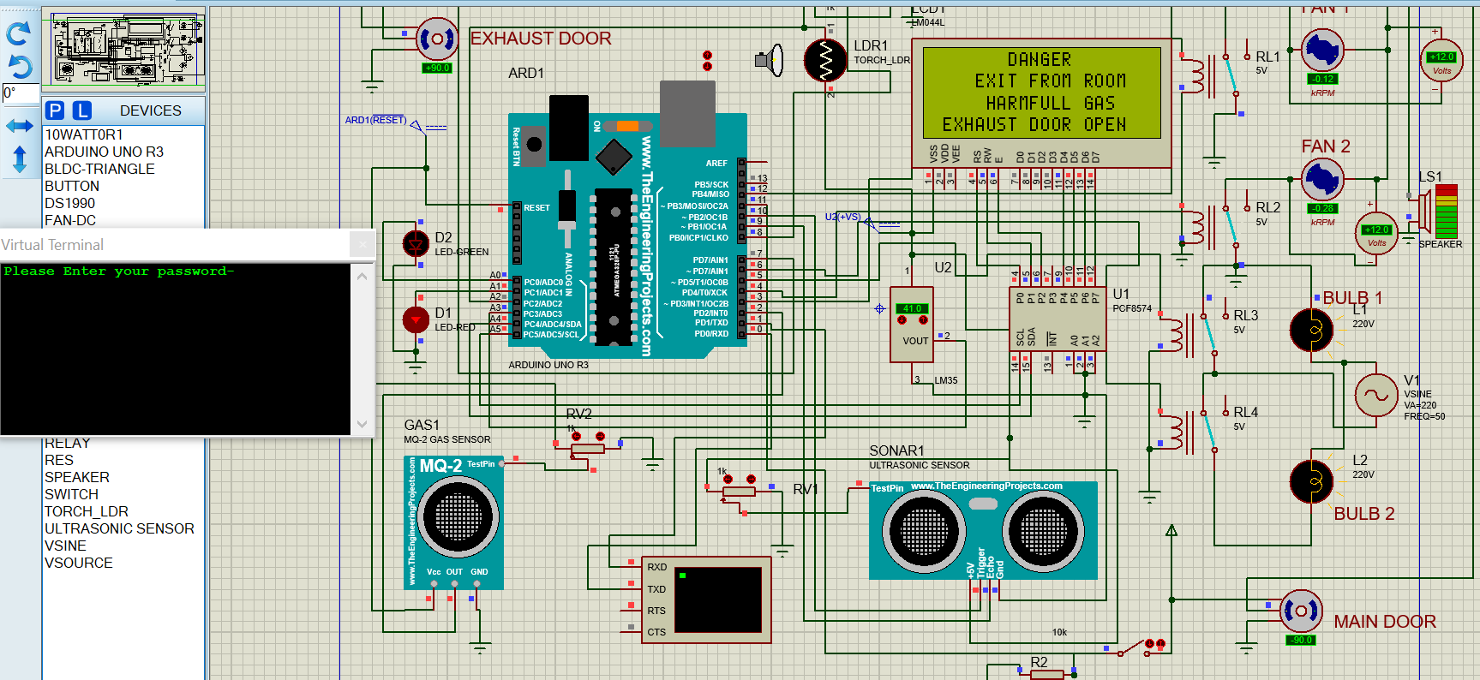

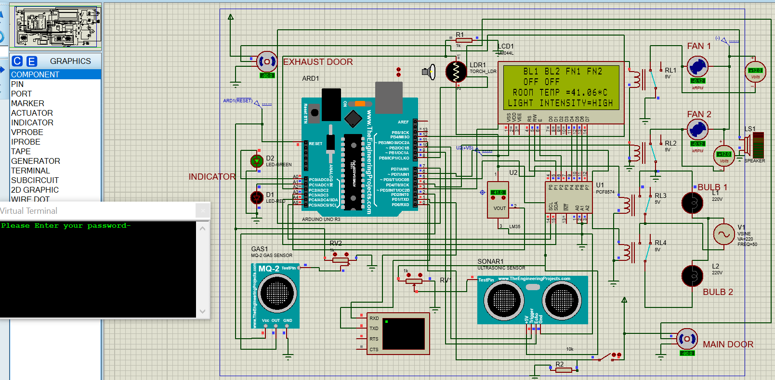

**Chapter 4.**

**4.1. Conclusion**

The system as the name indicates, ‘Home automation’ makes the system more flexible and provides attractive user interface compared to other home automation systems. In this system we integrate mobile devices into home automation systems. A novel architecture for a home automation system is proposed using the relatively new communication technologies. The system consists of mainly three components is a BLUETOOTH module, Arduino microcontroller and relay circuits. We hide the complexity of the notions involved in the home automation system by including them into a simple, but comprehensive set of related concepts. This simplification is needed to fit as much of the functionality on the limited space offered by a mobile device’s display. This report proposes a low cost, secure, ubiquitously accessible, auto-configurable, remotely controlled solution. The approach discussed in the report is novel and has achieved the target to control home appliances. Self made I.C. capable solution has proved to be controlled remotely provide home security and is cost effective as compared to the previously existing systems.

Hence we can conclude that the required goals and objectives of home automation system have been achieved. The system design and architecture were discussed, and prototype presents the basic level of home appliance control and remote monitoring has been implemented. Finally, the proposed system is better from the scalability and flexibility point of view than the commercially available home automation systems

**4.2. Future Scope**

Home of the future is a space for the digital natives. With the invention of lots of automation technologies featuring IOT and AI, home automation has become a reality. One can implement several of their tasks with just a single command of verbal instructions. These technologies can used to build fully functional home automation system and control smart home devices including smart lights, connected thermostats, and appliances.

There are several new technologies which can become a part of home in the near future:

* **Increased efficiency, control, and customization**: Artificial intelligence is set to make you lazy in the near future. Technology will become much more efficient and one will be able to control everything from volume to security from one central place. The devices will work automatically and you don’t need to waste your energy it will act upon user’s preferences. AI would revolutionize home by automatic threat detection and proactive alertness.
* **Integration of Smart home devices**: One can command it to control small things of home through voice and Smartphones. All the tech giants are working in the field of IoT to bring advancements in the home automation devices. In near future, homes will be equipped with such IoT devices which will make your daily lives work faster smoother and more accurate.  
  Mark Zuckerberg came up with a goofy proof-of-concept video showing off an idealized version of how his Jarvis system actually works. Google Home, which is Google’s smart speaker loaded with Google Assistant, was updated at last year’s Google I/O with a bunch of new features, including “proactive assistance”, also known as push notifications, hands-free free calling, Spotify, SoundCloud, and Deezer integrations, and more. Also, more recently, Google launched two more Google Home speakers, Home Max and Home Mini.
* **Smart spaces outside homes**: Smart parking through sensors will help to recognize whether the parking is available or not. Camera monitoring can be done and with the help of artificial intelligence and computer vision, both parking facilities and security can be provided. It would be a faster and smoother process and act as a reference for other smart systems to be build accordingly. Streetlights can also be automated through sensors and build for effective use for the people nearby.
* **Development of smart appliances**: The devices which we use to use like television, refrigerator and even the mirror is getting smarter today with evolution of technology. The smart mirror should not only act as a face video but also help to other tasks like listening to music and stuff. Televisions have become part of a centralized entertainment and can also be used for social media. The refrigerator has been upgraded to sense the temperature outside and operate accordingly. The washing machine will wash the clothes according to the clothes material and switch off after drying. They will keep on advancing as the technology evolves.
* **Personal home delivery**: Drones will be used to deliver the packages at the right time. They will replace the normal salesman job. They might also be used for several other tasks like monitoring the weather outside the home, returning something back to a relative’s home nearby and so on. They can also be used for monitoring the traffic in our locality.

**References:**

* <https://www.geeksforgeeks.org/future-of-home-automation/>
* <https://rcciit.org/students_projects/projects/ece/2018/GR30.pdf>
* <https://en.wikipedia.org/wiki/Home_automation>
* <https://www.researchgate.net/publication/324790988_Literature_review_on_home_automation_system_for_physically_disabled_peoples>
* <https://ieeexplore.ieee.org/document/9596421>
* <https://www.ijert.org/research/home-automation-using-arduino-and-smart-phone-IJERTCONV7IS06065.pdf>

This system focuses on the hand gesture

recognition algorithm and its corresponding UI. Ha